# Assessment Task 1 – Performance Project

| **Student Name:** |  | **Date:** |  |
| --- | --- | --- | --- |
| **Unit Being Assessed:** | ICTWEB513 - Build dynamic websites  ICTWEB514 - Create dynamic web pages | | |
| **Instructions for Assessment Task 1:** | This task provides an opportunity for you to demonstrate the skills and knowledge required for competence in this unit.  This Performance Project can be used in different scenarios and contexts. Your assessor will confirm the context and scenario (and therefore the background information) for this assessment task:  There are three (3) parts to this assessment task:   * Task 1.1: Develop a Plan * Task 1.2: Build a Prototype * Task 1.3: Meeting with Client   The completed documentation required for all parts of **Task 1: Performance Project** must be submitted in the relevant submission area of the [Canvas](https://canvas.tastafe.tas.edu.au/) LMS. | | |

**Background**

In this task you will begin the web development process by developing a plan, building a prototype, and meeting with the client to discuss plans and seek feedback.

The specific scenario and background information for your web development project will be provided by your assessor as a scenario pack. Alternatively, if you have a specific web project to work on (in a workplace for example), you may use this as your scenario if it is approved by your assessor.

**Task 1.1: Develop a Plan**

For this assessment, you must have a team and a project for the team to work on. Develop your website plan by filling out the template/exemplar provided below. Read through each heading as well as the blue text that describes each requirement in more details. When you are ready, delete the blue text and replace it with your own text.

**1.1.1. Summary of website requirements**

EventPulse are a Tasmanian event promotion business.

They would like a new website with the **purpose** of promoting tickets.

The primary **target audience** is eventgoers in the Australian market. Their predicted age is 15-50 years old and it is estimated that they will be accessing the site from mobile devices (70%) and desktop devices (30%). Event organisers are the secondary audience. They will use the site to post new ads.

The client is **expecting** a working prototype of the website within three weeks. Planning to be completed and confirmed with the client within one week.

The required **functionality** includes a homepage that displays a list of upcoming events. This will be accessible by the public. Each event will have a date/time specified and will not be displayed once this has passed. All events will be displayed in chronological order - soonest first. There will also need to be a Post-New-Event page available via login so that event organisers can post events themselves. All event and user data will need to be stored in a database.

The client has only provided a few requirements when it comes to the **user interface**. They have expressed openness to suggestions and would like the developer to take charge. They want to ensure their logo is consistently displayed between pages, and that there is a general consistent feel across the site. They have also stated they would like "basic accessibility features". In discussing this with the client, they have suggested that they do not require full WCAG compliance, rather a best-effort from the developer.

**1.1.2. Legislation, standards, and guidelines**

**Disability Discrimination Act 1992**

Relates to the accessibility requirements of the website. This may not apply during this phase of development, however EventPulse are planning to eventually add ticket sales and member communications via email.

**Copyright Act 1968**Relates to images and content on the website. Images used on the site, as well as images uploaded by event organisers will need to be monitored for copyright compliance. A policy should be developed and added to the website.

**Spam Act 2003**

Relates to emails set to clients from the website. This will not apply during this phase of development, however EventPulse are planning to eventually add ticket sales and member communications via email.

**Web Content Accessibility Guidelines 2.1**

Relates to the accessibility requirements of the website.

**1.1.3. Site map**

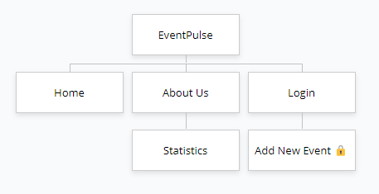

**1.1.4. Sketch (with dynamic sections highlighted)**

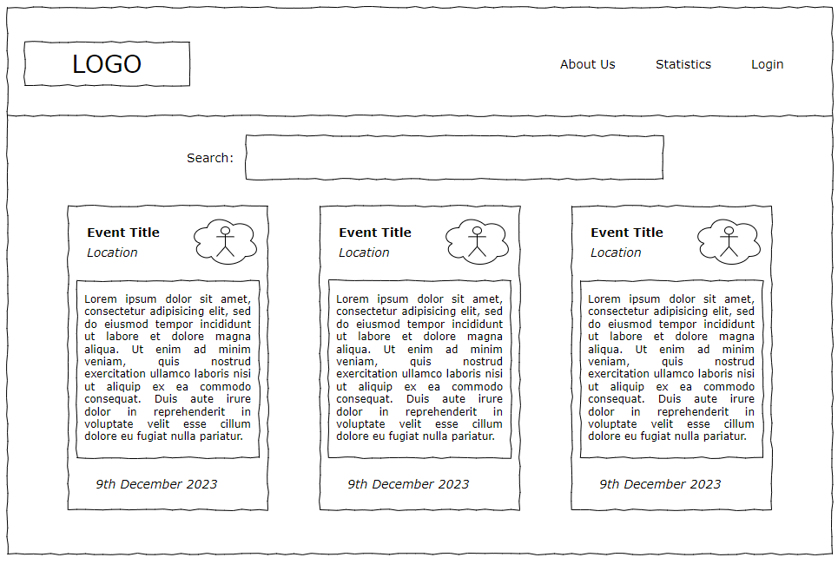

The Search box highlighted in GREEN will utilise client-side scripting to filter the listed events based on the entered search term.

The events list highlighted in RED will utilise server-side scripting to provide the event list in JSON format, an client-side scripting to render the list on the HTML page.

**1.1.5. Technologies**

Frontend:

* HTML
* CSS
* JavaScript
* Bootstrap 5
* Vue 3

Backend:

* Node.js
* Express
* Express-session
* MongoDB

**1.1.6. Data storage**

MongoDB used as the database.

Database: eventpulse

Collections: users, events

Sample database record/document:

[

    {

        "title": "Gyroscope & Bodyjar - No Touch Obsession ",

        "imageURL": "https://assets.oztix.com.au/image/ecb94a3c-1423-4361-9fc3-300d409a76b3.png?width=350&height=175",

        "costString": "$61.20",

        "date": "2023-09-14T19:00:00.000Z",

        "description": "Two of Australia’s most iconic…"

    }

]

**1.1.7. Task breakdown**

1. Initial meeting with client to discuss proposed brief (2 hours)
2. Research and analysis of market and competition (4 hours)
3. Develop site architecture, output sitemap (2 hours)
4. Develop mockups and wireframes and seek client approval (2 days)
5. Install and test required technology stack (1 hours)
6. Configure MongoDB and create database with sample data (1 hour)
7. Build the backend with Node.js and Express etc (2 day)
8. Build the frontend (adapt the mockups to become the active frontend pages) (1 day)
9. Ensure frontend and backend integrate harmoniously (1 day)
10. Perform testing: UX, Browser, Security, Accessibility (1 day)
11. Optimize/adjust based on test results (1 day)

**Task 1.2: Build a Mockup**

You will need to build a prototype of the website user interface. In other words, you will create a ***mock-up*** the **main page** of the website you are building.

The prototype must be built with HTML and CSS (at a minimum).

A prototype generally shouldn’t need to contain any significant scripting – it just has to look right. For example: A web page would normally use scripting to grab data from a server/database to display on the page, but in this case, you would just manually add some sample data in the HTML page of your prototype.

Once you begin the coding phase of website development, this prototype can be used as a template/starting point for building your pages.

Once complete, save your prototype somewhere safe. It will be used in Task 1.3 and will also be included in the submission for this assessment task.

**Task 1.3: Meeting with Client**

In this task you will arrange and participate in a meeting with the client.

In the meeting, you will discuss your plan (**Task 1.1**) and demonstrate your prototype (**Task 1.2**).

Specific points to cover with the client during the meeting include:

* Show and discuss the website plan (**Task 1.1**)
* Discuss the site capabilities
* Demonstrate the prototype (**Task 1.2**)
* Any recommendations that would increase capability and/or efficiency of the site, or improve the development process
* Negotiations on site capabilities and efficiency

You must seek and document feedback received from the client. Use **Template 1.3.1** below to record details of the meeting. Copy the template to a new document, fill in details, and store it ready for submission with other items for Task 1.

|  |  |
| --- | --- |
| Template 1.3.1 Meeting and Client Feedback Log | |
| **Meeting date/time** |  |
| **Attendees** |  |
| **Location** |  |
| **Meeting agenda** |  |
| **Feedback received/notes** |  |
| **Summary of changes to plan (based on feedback)** |  |

**Assessor Checklist (Task 1.3: Meeting with Client)**

Your TasTAFE Assessor will verify that you have completed the following:

|  |  |
| --- | --- |
|  | 1.3.2: Candidate has produced at least one prototype of the website user interface. The prototype is professionally presented. |
|  | 1.3.3: The presented prototype meets the design requirements of the client. |
|  | 1.3.4: Candidate negotiates key aspects of the design and development with the client. |

**Submission**

The following items must be submitted for Assessment Task 1:

|  |  |
| --- | --- |
| **Task** | **Submission requirement** |
| Task 1.1: Develop a Plan | The filled plan document |
| Task 1.2: Build a Prototype | A folder containing the prototype web page |
| Task 1.3: Meeting with Client | The filled **Template 1.3.1** in a document |

All the items listed in the submission requirements above should be added to a ZIP file (not 7z) and submitted in the relevant submission area of the [Canvas](https://canvas.tastafe.tas.edu.au/)